There are many commodities that you can invest in (gold, silver, oil, etc). We will talk about gold only.

Gold and Gold ETFs
Reasons to buy gold:
- Limited supply: governments can print as much bank notes as they want. So, a currency can deteriorate at any time whatever how strong it was. On the other hand, gold is limited in nature and always has its valuable value. So, it will never ever lose its value.
- Adds diversification to your portfolio: this is the most important reason. If there is a market crash, most of the stocks will go down even if you are diversifying across different sectors and securities. In such time, it is good if your portfolio contains an asset that is uncorrelated to the stock market, and gold is one of these assets; when the stock market crashes, people panic and start selling their stocks to buy gold. So, stocks go down and gold goes up. Mohsen Hassan calculated the correlation between stocks returns and gold returns in the last 50 years. It was found to be -0.2, perfect! They are really uncorrelated.
- Positive historical performance: Mohsen Hassan has calculated the average returns of gold from 1970 to 2018 and it was found to be 7.67% (you can find the numbers in the net worth excel sheet in section 5 – Investment Vehicles).
Popular gold ETFs:
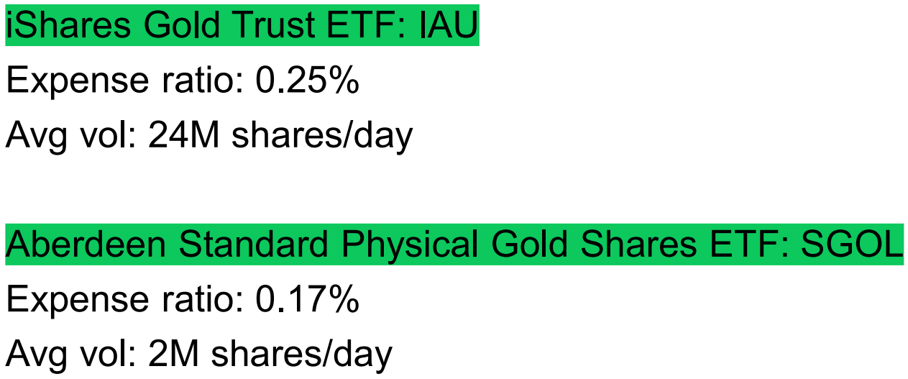

Other Investment Products
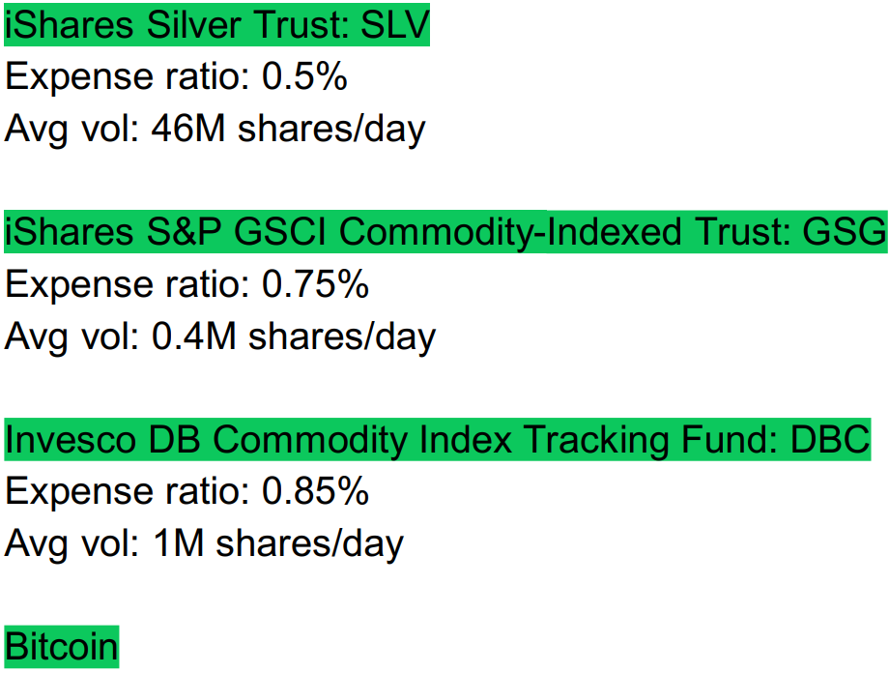

Emerging Market ETFs
Emerging market means countries that are not yet developed; they are still growing. For example, the US is a developed country, while Egypt is a growing country. If you live in the US, you might want to invest in Egypt so that you get exposed to an emerging market that can sometimes achieve substantial returns, but of course it is riskier. Also, if you live in Egypt, you might want to invest in the developed market of the US so that you decrease your risk. So, it is good that you invest in your country’s market (since same currency, you understand the different circumstances, etc) as well as other markets for diversification.
Popular ETFs for emerging markets:
